**19 July 2015**

**Memorial service for the Cypriots who were killed during the 1974 coup d’état and Turkish invasion in Cyprus at the Holy Cathedral Church of Saint Nikolaos in Rotterdam, 19 July 2015**

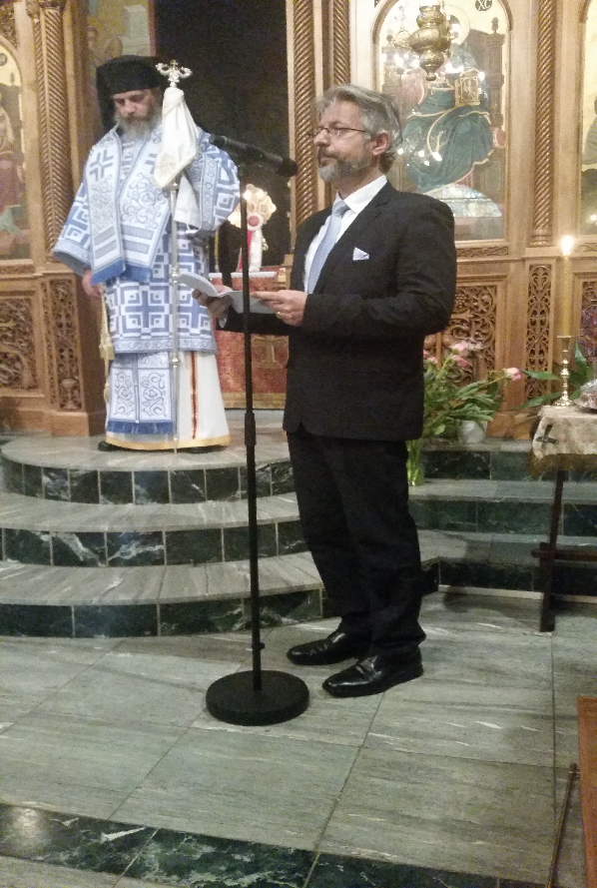

On Sunday July 19th 2015, a national memorial service for those who were killed during the 1974 coup d’état and the subsequent Turkish invasion was held at the Holy Cathedral Church of Saint Nicolas in Rotterdam, for a second consecutive year in the Netherlands. His Grace Bishop Porfyrios of Neapolis, Head of the Representation of the Church of Cyprus to the European Union, presided of the Divine Liturgy as well as of the commemoration service. The memorial speech was delivered by H.E. the Ambassador of the Republic of Cyprus to the Kingdom of the Netherlands, Dr. Kyriacós Kouros. Numerous Cypriots and Greeks who are residents of the Netherlands attended the memorial service. The service was followed by a short gathering at the House of the Union of the Greeks in the Netherlands.